Multi-Agent Security Incident Response System with Runtime Watchdog and Adversarial Guardrails

Project Code
UOS-CS-27-MAS-WnG
Project Advisor
Mr Farooq Javed
Project Manager
Dr. Muhammad Ilyas
Project Team
Mishal Irum(BSCS51F23S031) Team Lead
Barira Khan (BSCS51F23S002) Team Member
Saad Ullah Rasool (BSCS51F23S043) Team Member
Submission Date
13-oct-2026
Table of Contents
1. Abstract 3
2. Background and Justification 4
3. Research Methodology 5
4. Project Scope 7
5. High level Project Plan 7
6. References 9

Abstract
Security operations centers defend organisations against cyberattacks, but analysts cannot keep pace with the volume of alerts, so AI agents that investigate and respond to incidents are now being adopted. This autonomy creates a new problem: logs contain text written by attackers, so hidden instructions in a log can steer an AI agent into harmful actions such as blocking a legitimate server, and manipulated messages between agents can spread the damage.
Existing commercial platforms and general-purpose agent frameworks offer approved workflows, policy controls and AI-based checkers. In the sources reviewed, they are not evaluated against poisoned logs or tampered agent messages in incident response, and AI-based checkers can themselves be bypassed.
We propose a multi-agent incident-response prototype in which Detection, Investigator and Response Planner agents only propose actions. A code-based Orchestrator allows only typed, structured messages between agents, and a deterministic Watchdog validates every action against a schema, protected IP ranges and an allowed-action list before a separate executor runs it, with human approval for high-risk actions. In an isolated Docker lab, a red-team agent attacks the system with log-poisoning and message-tampering attacks.
We compare two configurations (with and without Watchdog and Orchestrator) using Attack Success Rate, detection precision and recall, False Block Rate and added latency. The unprotected pipeline is the baseline; published injection-success figures from a single-analyst study serve only as a loose reference. Unlike closed commercial platforms, the lab is open and reproducible. The aim is not to eliminate prompt injection but to limit and measure the damage it can cause.

Background and Justification
Security operations centers receive more alerts than analysts can investigate. Vendors now offer multi-agent AI systems that investigate and remediate incidents, acting autonomously or with human confirmation [1], and restrict the AI to approved workflows [2]. This autonomy creates two risks: attacker-controlled content in logs can steer the AI, and messages passed between agents can be manipulated.
Existing tools. Torq coordinates investigation, runbook, remediation, and case-management agents [1], limited to approved workflows [2]. AG2 offers policy-driven safeguards over messages between agents and between agents and tools [3]. Meta's LlamaFirewall AlignmentCheck uses an LLM to monitor agent conversations and judge whether the system is progressing toward the user's goal [4]. In the sources reviewed, Torq does not report evaluation against poisoned logs or manipulated inter-agent messages [1], [2]. AG2 is general-purpose and not designed for incident response [3]. LLM-based checks such as AlignmentCheck can be evaded by control-flow hijacking attacks [4].
Existing research. Log fields such as user agents and URLs are attacker-controlled and can carry instructions to an LLM analyst. Tested defences reduced average injection success from 26.6% to 11.8%, not to zero [5]. ControlValve enforces permitted control-flow graphs between agents, and shows attacks that evade LLM-based alignment checks [4]. Agent-in-the-Middle shows that an adversarial agent that intercepts and rewrites inter-agent messages can compromise an entire multi-agent system [6]. These studies examine a single LLM analyst [5] or general-purpose tasks [4], [6], not a multi-agent incident-response pipeline that executes remediation.
Recent studies also show that probabilistic language model guardrails do not always keep things safe. This means that code-based symbolic guardrails are needed to make sure unsafe tool calls are blocked [7]. These studies also show that backdoor attacks can affect the thinking process of the model. These attacks are called Thought-Attacks. They do not change the text. Because of this just checking the Response Planner is not enough. Every single step and every tool call must be checked by a runtime Watchdog[8].
Gap. In the sources reviewed, no single work combines (i) a multi-agent incident-response pipeline with real remediation, (ii) hard limits on what its agents may exchange, and (iii) a red-team agent that attacks both log input and inter-agent messages and measures the outcome.
Potential contribution.
- A fixed-order pipeline (Detection → Investigator → Response Planner → Watchdog → Executor) that runs safe actions in a container, with human approval for high-risk actions.
- A communication limiter that allows only typed, structured messages between agents, restricting content as well as channels.
- A deterministic code-based Watchdog that validates schemas, IP ranges, and allowed actions, so that safety does not depend on an LLM judge.
- A red-team agent that reproduces log-poisoning [5] and message-manipulation attacks [6], reporting attack success rates across different configurations.
- An open, reproducible lab environment.

Project Methodology
The methodology followed in the project will go through the following phases:
Phase 1: Lab and Core Pipeline. An isolated Docker lab is built with a victim web server producing real access logs and an attacker container running Nmap scans and brute-force logins. Three agents are implemented: a Detection Agent (Llama-3-70b via Groq and LangChain) flags anomalies, an Investigator Agent builds a threat timeline (first from a simple log lookup, later with ChromaDB incident memory built from earlier lab runs), and a Response Planner Agent returns structured actions (e.g. BLOCK_IP) validated by Pydantic. A deterministic LangGraph Orchestrator fixes the flow as Detect → Investigate → Plan → Validate → Execute, and agents exchange only typed messages with allowed fields, never raw log text. The baseline pipeline simulates actions; real execution is enabled together with the Watchdog.
Phase 2: Watchdog and Execution. A safety policy defines protected IP ranges, allowed actions and rate limits. The Watchdog checks every proposed action against this policy before a separate code-based executor runs it in the victim container. High-risk actions wait for human approval in a Streamlit dashboard.
Phase 3: Red Teaming and Evaluation. A red-team agent generates attacks: hidden instructions in log fields, role-play overrides, encoded payloads, tampered agent messages and poisoned ChromaDB entries. Attacks run against two configurations: protected and unprotected pipelines. Runs are repeated because outputs vary. An attack counts as successful if a forbidden action is approved or executed, which is checked from the system state. Metrics are Attack Success Rate, detection precision and recall, False Block Rate and added latency.
Tools: Python, Docker, LangGraph, LangChain, Groq and Gemini APIs, Pydantic, ChromaDB, Streamlit, Git.

Project Scope
This research covers a multi-agent prototype in which Detection, Investigator and Response Planner agents analyze server logs and only propose actions. A code-based Orchestrator fixes the order of the agents. A Watchdog validates every proposed action against its schema, IP range and an allowed-action list before a separate code-based executor runs it, and high-risk actions require human approval. The system is tested in an isolated Docker lab with attacker and victim containers, using one attack scenario with several variants of logs containing hidden instructions, generated by a red-team component. Results are compared across two configurations (with and without orchestrator and watchdog) using pre-trained LLM APIs. Because these models may change over time, each test is repeated and the model versions used are recorded.
The research does not cover model training or fine-tuning, real or production systems, or a complete solution to prompt injection; the aim is to limit the damage it can cause.

High level Project Plan
The project is planned in eight phases from September 2026 to May 2027, with documentation and implementation running in parallel. The system is built first as an unprotected baseline pipeline and then protected with message limits and Watchdog guardrails, before the red-team agent compares the four configurations.
Phase | High-Level Activity | Time Allocated | Milestone / Submission Deadline | Assigned Resources
1 | Literature Review & Proposal Preparation | Sep 08 – Oct 13, 2026 (5 weeks) | 13 Oct 2026: Proposal Submission | FYP Team, Supervisor, Research Papers
2 (Parallel) | Task 1: SRS & Threat Modeling; Task 2: Detection Agent | Oct 14 – Nov 10, 2026 (4 weeks, includes 1 week for exams) | 10 Nov 2026: SRS Submission | FYP Team, Groq/Gemini, Docker
3 (Parallel) | Task 1: Design Document; Task 2: Investigator & Planner Agents (simple log lookup) | Nov 11 – Dec 18, 2026 (5.5 weeks) | 18 Dec 2026: Design Document Submission | FYP Team, Groq/Gemini, Docker
4 | Orchestrator & Unprotected Baseline Pipeline (actions simulated) | Dec 21, 2026 – Feb 05, 2027 (7 weeks, includes 1 week for exams) | 05 Feb 2027: Baseline Pipeline Verified | FYP Team, Docker, LangGraph, Pydantic
5 | Watchdog Guardrails, Human Approval & Dashboard | Feb 08 – Mar 05, 2027 (4 weeks) | 05 Mar 2027: Protected Pipeline with Live UI | FYP Team, Pydantic, Streamlit, Docker
6 | ChromaDB Incident Memory | Mar 08 – Mar 19, 2027 (2 weeks) | 19 Mar 2027: Memory-Augmented Investigator | FYP Team, ChromaDB
7 | Security Testing & protected vs unprotected pipeline comparison | Mar 22 – Apr 23, 2027 (5 weeks, includes 1 week for exams) | 23 Apr 2027: Security Comparison Results | FYP Team, Groq/Gemini, Attacker container
8 | Final Report & Defense Preparation | Apr 26 – May 21, 2027 (4 weeks) | May 2027: Final Defense | FYP Team, Supervisor
Table 1: High-level project plan with milestones and assigned resources
Figure 1: Phase-level Gantt chart (MS Project view); grey bands are examination weeks
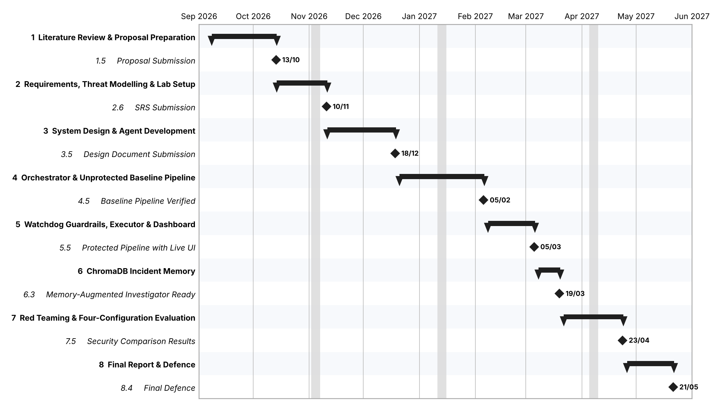
The detailed task-level plan (task sheet, predecessors, resource sheet and full Gantt chart) is attached as a separate MS Project–style document.

References
The numbers below match the bracketed citations in the above text.
- Torq. (n.d.). AI agents for the SOC. https://torq.io/ai-agents-for-the-soc/
- Dey, V. (2023, August 2). Torq launches Torq Socrates, an AI agent for Tier 1 SecOps threat resolution. https://venturebeat.com/ai/torq-launches-torq-socrates-an-ai-agent-for-tier-1-secops-threat-resolution/
- AG2. (n.d.). Safeguards. https://classic.docs.ag2.ai/0.14.1/docs/user-guide/advanced-concepts/orchestration/group-chat/safeguards/
- Jha, R., Triedman, H., Wagle, J., & Shmatikov, V. (2026). Breaking and fixing defenses against control-flow hijacking in multi-agent systems. In International Conference on Learning Representations (ICLR 2026). https://arxiv.org/abs/2510.17276
- Pandey, R., & Bhujang, A. (2026). Poisoning the Watchtower: Prompt injection attacks against LLM-augmented security operations through adversarial log content. arXiv. https://arxiv.org/abs/2605.24421
- He, P., Lin, Y., Dong, S., Xu, H., Xing, Y., & Liu, H. (2025). Red-teaming LLM multi-agent systems via communication attacks. Findings of the Association for Computational Linguistics: ACL 2025, 6726–6747. https://aclanthology.org/2025.findings-acl.349/
- Y. Hong, Y. She, E. Kang, C. S. Timperley, and C. Kästner, Don’t Make Models Guess Security and Safety: Symbolic Guardrails for Domain-Specific AI Agents. arXiv:2604.15579, 2026. https://arxiv.org/pdf/2604.15579
- W. Yang, X. Bi, Y. Lin, S. Chen, J. Zhou, and X. Sun, Watch Out for Your Agents! Investigating Backdoor Threats to LLM-Based Agents, in NeurIPS, 2024.
https://proceedings.neurips.cc/paper_files/paper/2024/file/b6e9d6f4f3428cd5f3f9e9bbae2cab10-Paper-Conference.pdf

